

SD FCCLA State Talent Show Registration Form
Email completed registration form to Emma Sonsteby by Wednesday, April 23 at ES4473@k12.sd.us.
A schedule of performance times will be emailed to participants before state meeting. Submit your
application today! We look forward to showcasing your talent!
Chapter________________________________ Adviser ________________________________
Participant E -Mail ________________________ Adviser E-Mail ___________________________

This registration is for (check one): Individual Entry ______ Group Entry ______

Student’s name (if Group Act, list all students participating here)
Name | Student E-mail | Cell Phone Number
1.
2.
3.
4.
5.
6.
7.

Type of Talent (check one category): Dance_____ Skit _____ Song _____ Other _____

If Other (Please specify) ________________________________________________________________
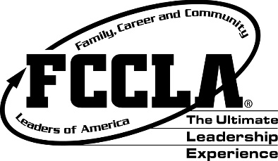
Title of Performance (or Group Name)________________________________________________

Length of Performance __________________________________________________________________

Rules:
- Must supply own music, props and music system.
- The length of the act should not be more than 3-4 minutes.
- Performances MUST follow school appropriate language, dress code and music choice.
Any inappropriateness may disqualify an act at the show and is up to the discretion of
the state officers, state adviser, and Board of Directors.
Event date – April 28, 2025 @ 4:00 PM

Include a brief description of act to be used as an introduction (Lip Sync, Dance, Magic Act, Vocal, Juggling, etc.):

