South Dakota FCCLA Blazer Policy/Contract
2021-2022 School Year
(June 1, 2021 through Tuesday 11:00 AM, at 2022 SD FCCLA State Leadership Conference Unless Need for NLC)

South Dakota FCCLA has purchased a number of official, red blazers in assorted sizes to benefit National Leadership Conference attendees due to new dress code requirement. Blazers will be used by affiliated South Dakota members.
Please complete this blazer contract/check out form and return to SD FCCLA State Adviser.
The following policies will govern the management of the blazers.

- Only affiliated members may acquire blazers
- Rental cost - $20 per year – check made payable to SD FCCLA at time of rental/check out
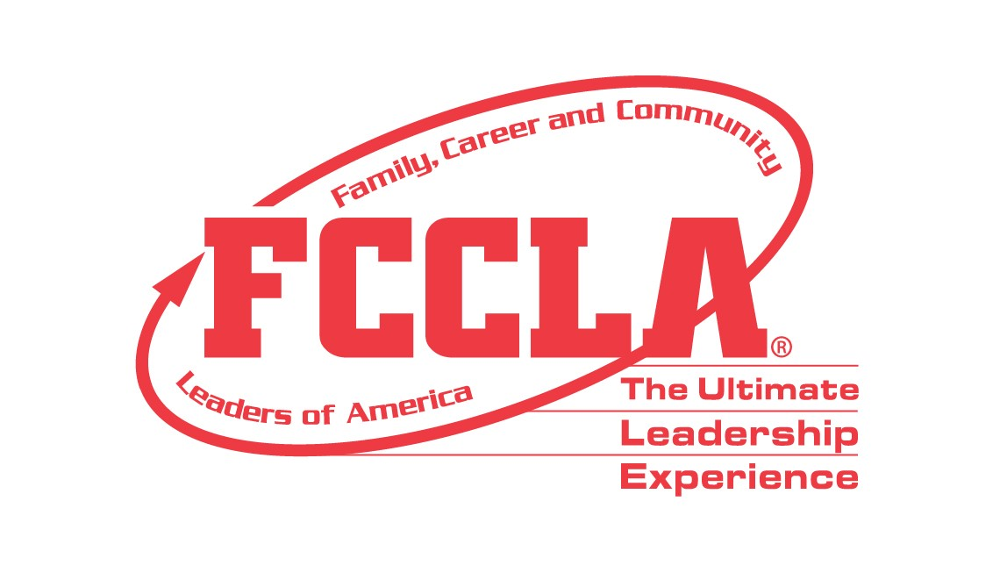
- This is the only rental fee option and is non negotiable
  - Ex. May not rent for a shorter time/lesser fee
- In priority order for receiving blazers are:
  - State/National officers
  - Regional officers
  - Officer candidates
  - STAR Event/Knowledge Bowl participants
- Blazers being used through the State Leadership Conference must be returned at the end of the conference.
- Blazers being rented only for the National Leadership Conference can be returned to the state adviser at the summer SDACTE Conference unless other arrangements are made.
- It is the responsibility of the chapter to arrange drop off/pick up of blazers from the state adviser.
- In the event that a blazer is returned in less than perfect condition the chapter will be assessed a fee of up to $75.

If sleeves are a little too long, insert and tack an extra set of regular shoulder pads, which shorten sleeve length if too long. Blazers may not be altered.

I, ______________________, of the _____________________ FCCLA Chapter agree to the South Dakota FCCLA
blazer rental guidelines and will rent a blazer from South Dakota FCCLA for the amount of $20 for the term of __________________________________________ and return the blazer in like new condition on the labeled hanger provided, and stored in the black, labeled storage bag provided at the time of check out. The state office will dry clean blazers upon return after state leadership conference. If blazer is in need of repair or button replaced, I agree to pay additional fee(s) up to $75.00 if repair not completed before returning.
PICK UP DATE: ____________________________________________________________
RETURN DATE: ___________________________________________________________

Blazer Size: ___________ Circle One: Male Female Blazer #: _____________________

___________________________________ ______________________________________
Student Signature Adviser Signature

___________________________________ ______________________________________
Print Student Name Date

Date Blazer Returned: ______________________ _____ Labeled Hanger Included _____ Black Storage Bag Included
Condition Upon Return: _____Excellent _____Good _____Average _____Needs Repair

Fee Assessed: Yes No (Circle One) If circled “yes”, fee due: $______________________

Repairs needed:

