2015-2016 District STAR Event Registration Instructions
1. Log into the system using your username and password you used to affiliate students (this is usually your chapter ID #
and then a password you selected).
2. Advisers verify your information in order to “open” the new year for your chapter. If you skip this step, you will not
be able to see anything on your registration form for this year.
3. Enter only students competing at district meeting into the system. Click on the “Add Student” tab to add students –
as shown with the purple arrow below.
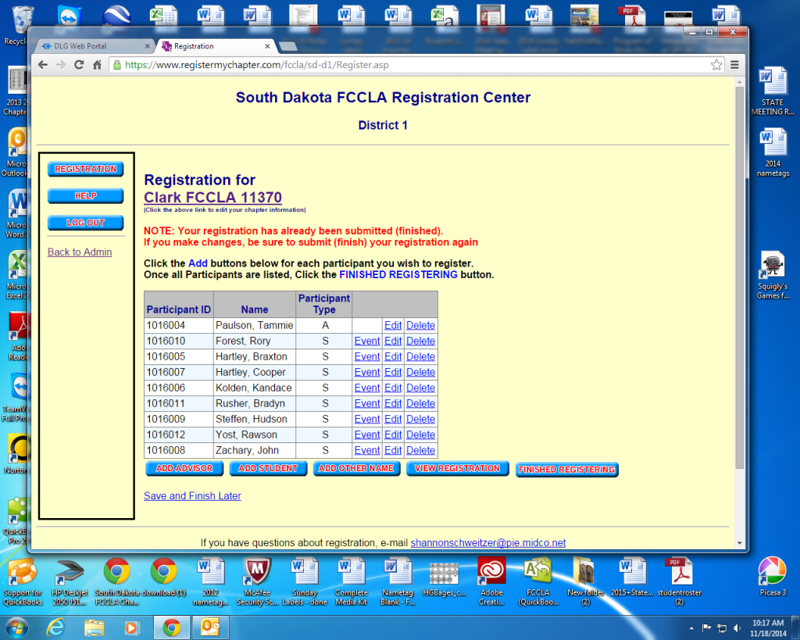
4. Select students by clicking on the “Search” tab – shown below with the purple arrow. This will bring up all affiliated
members that are eligible to compete. 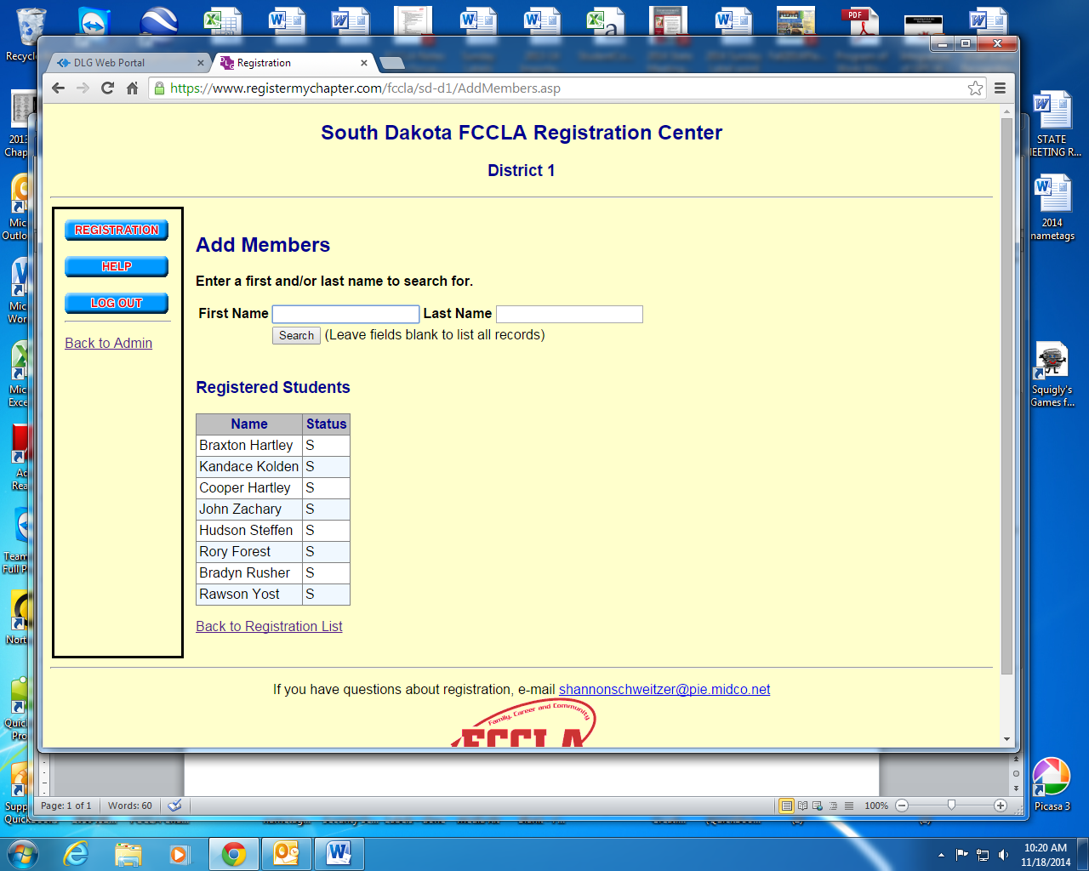
5. Then you can select “”Student Participant” or leave it as “Not Attending” for those not competing at districts. Also,
identify the level they are competing at “Jr”, “Sr”, or “Occ”. See purple arrows below. Finally hit “submit at the
bottom of the page once you have selected all of your students.
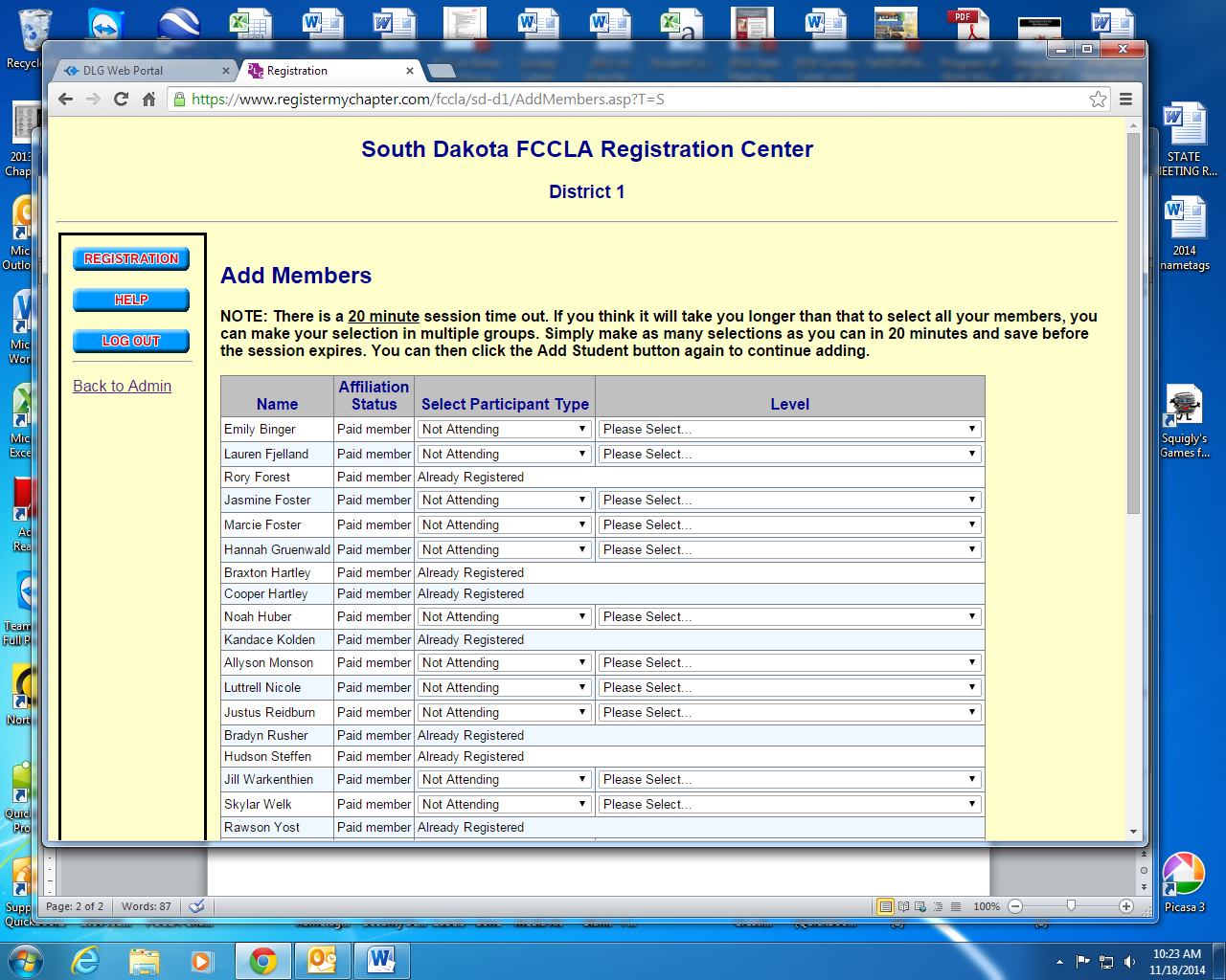

6. This will bring you back to the front registration page. By clicking on the “Event” tab, you will then be able to identify
teams and events.
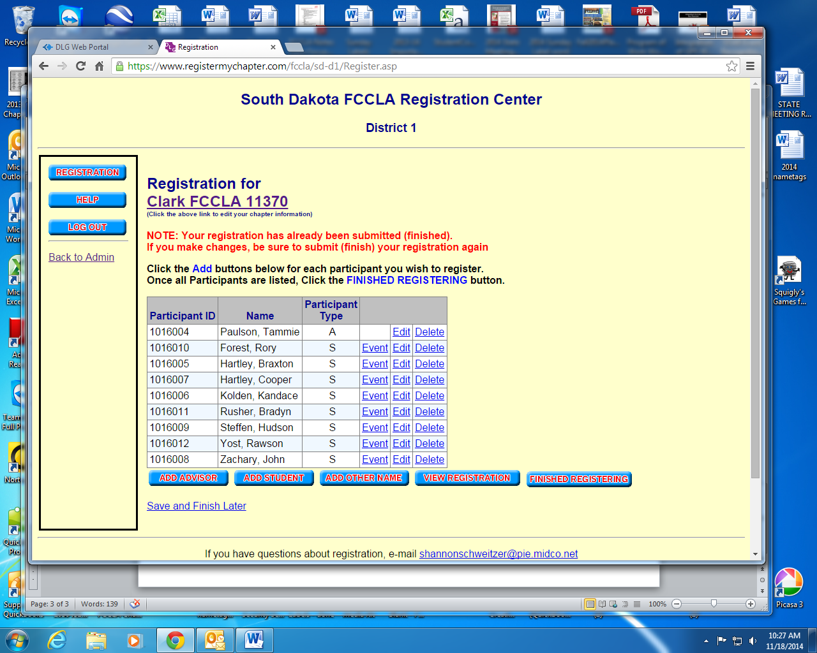
7. You can select either Illustrated Talk, Career Investigation or Job Interview (Juniors will only show Illustrated Talk and Career Investigation). Also, you can identify which teams/individuals at this point. Under the “Team #” column, put the same Team # for those participating as a group or give individuals their own Team #. For example: Joe, Jane, and Jerry are competing as a team so they will all have Team #1; while Jake is competing individually so he will have Team #2, etc. Make sure you click save once you have made your selections.
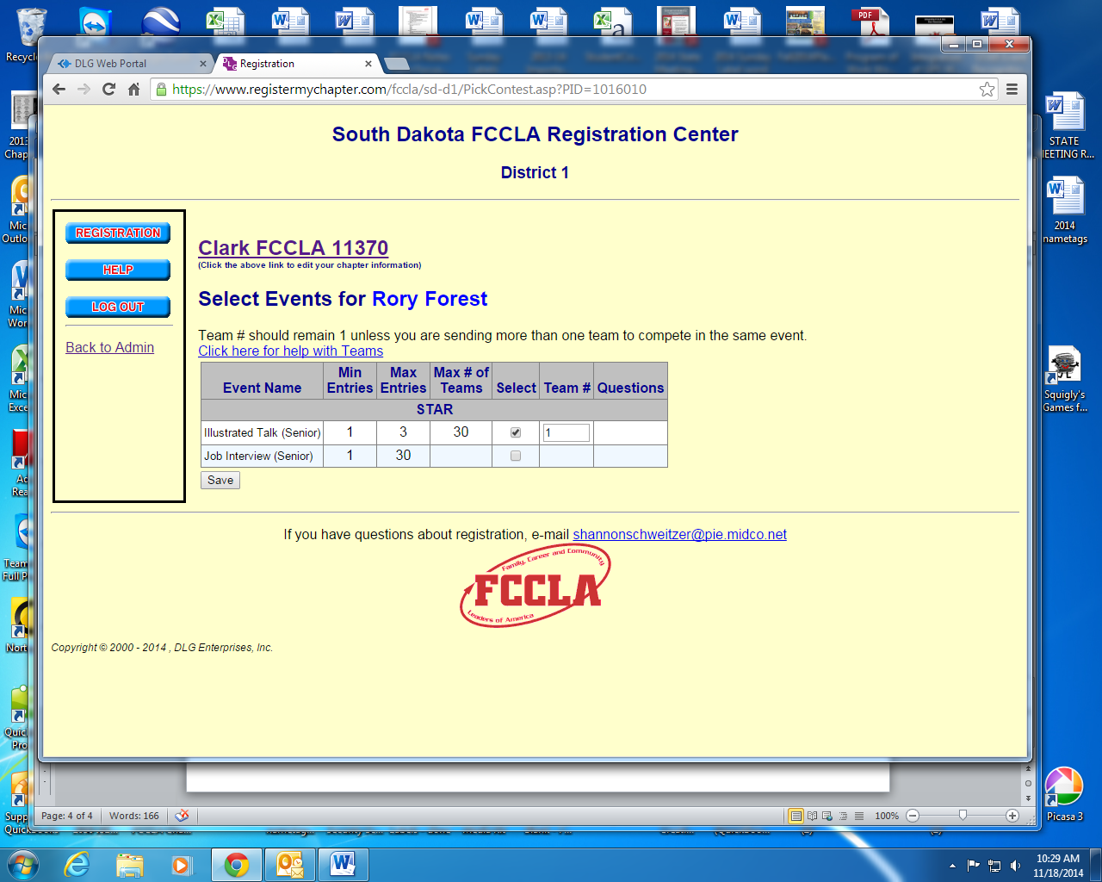

8. Once you have entered all your students competing at districts, click the “Finished Registering” button. If you are uncertain if the registration is correct, you can always click the “View Registration” button and it will let you see what has been registered.
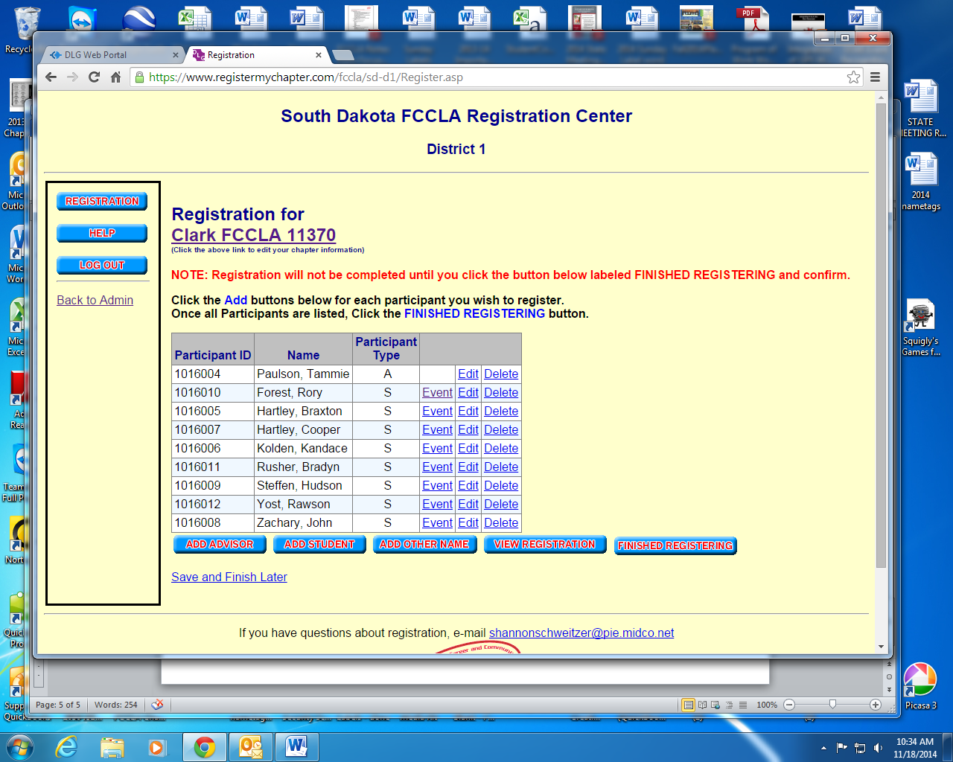

9. If you have problems are need help please don’t hesitate to email bellj@brookings.net or call 692-6056.

