The 2017 State Leadership Conference portal is now open for registration: https://www.registermychapter.com/fccla/sd .
You will see a few new options that we are offering this year. Please read details below before registering.
Once you have registered, please submit your invoice to your business manager to pay as soon as possible. I know many schools
only cut checks on certain days of the week. Please print and mail a hard copy of your registration along with your check. It takes extra time for me to log in and find your registration to print off your invoice, plus it is an added expense for the state association.

Each school will be responsible for bringing 2 judges to help at state meeting. If you do not know the names of the judges yet, just put in your school name and Judge 1 and school name Judge 2. Please send judges names as soon as you have them confirmed. Your other choice is to have the state provide your judges and pay the $75 judges fee on the registration. If you have extra judges available that are chaperones, etc., we would be happy to use their expertise too. If you are still having trouble, think about your FCCLA alumni members that may be attending school or living in the Sioux Falls area.

Registration:
Regular-Noncompeting Registration is $55
STAR Event Registration is $60.00 (Knowledge Bowl for teams advancing is in the drop down, but will not be counted as an event to prevent registering for a STAR Event).
To avoid problems with juniors needing to register in the senior division for a team event, I have set up the system to have a drop down to enter the category they are supposed to be in (junior, senior, occupational). If you have a 9th grader in a team with a 10th grader, just use the drop down and put both team members in the senior division. Hopefully this will eliminate the locked registration site. It is set up this way for Illustrated Talk and Knowledge Bowl. If you have another event that is affected, please let me know and I will reset that specific STAR Event too.

A State/National Meeting t-shirt will be offered for sale. We will place an order on February 24th for the number of t-shirt orders submitted during registration. They will NOT be available for sale at state meeting. We are not in a position to carry over left over t-shirts. The state t-shirt contest winning design is on the t-shirt.
Shirt prices: Small – Extra-Large: $12.00; XXL: $14; XXXL: $15. The t-shirts are white and have short sleeves. The t-shirt design is attached below. The t-shirt back design will have the entire set of thumbs up hands, I could not get the entire picture in the snip.
A new Monday night event will be offered, but there will be an extra fee involved ($20) to cover costs. We are offering a “canvas painting” class where you will take home an 11” X 14” painted canvas. Depending on numbers that sign up, there will be a possibility of more than one design to be painted. Creative Spirits of Sioux Falls will bring the event to the convention center for ease of participating. This event will be offered to only those who sign up during registration as supplies need to be ordered and a location set up.
We will also have the dance option in a little different format, a movie option, and an energized exercise option.
A reminder that the registration due date has been moved to February 21, 2017. Late registration fees will kick in at 12:01 a.m. on Thursday, February 23, 2017. Please contact me with questions and concerns.
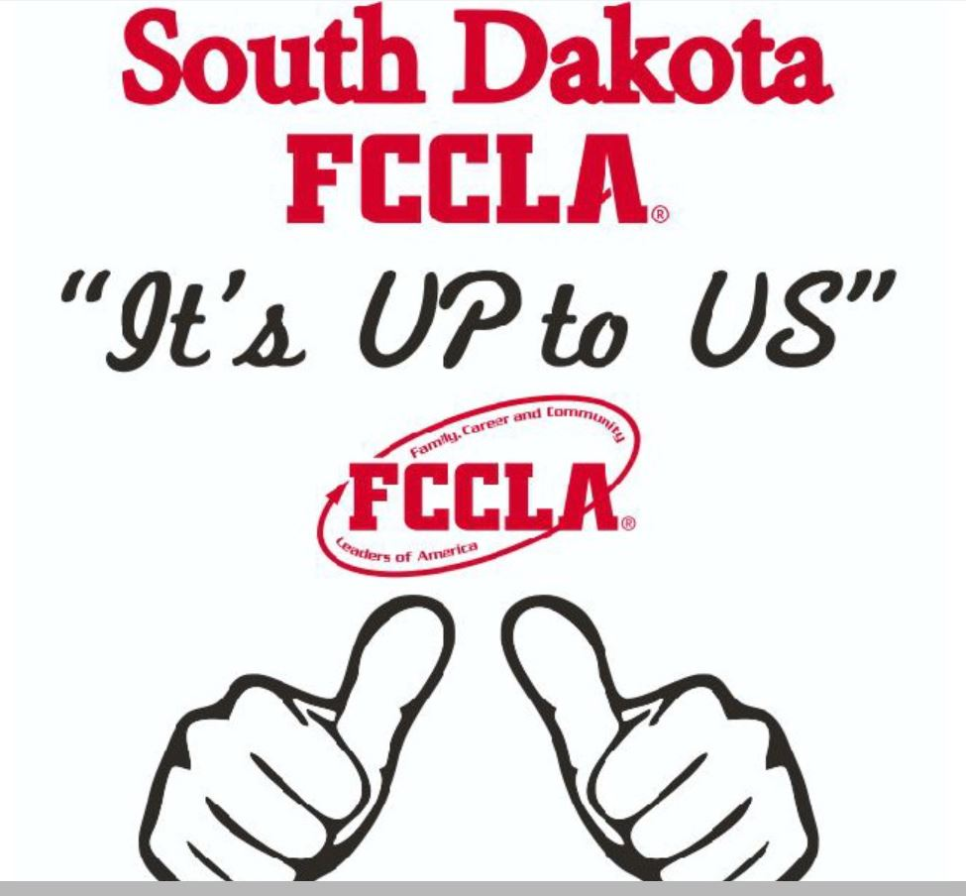
BACK OF SHIRT FRONT OF SHIRT

