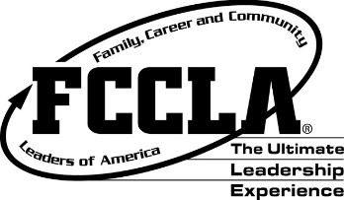
South Dakota Association
Family, Career and Community Leaders of America
State Leadership Team Application Instructions

Please complete the following instructions for the State Leadership Team Application. Two hard copies of the application need to be sent (one to State Adviser & one to Leadership Team Adviser) and postmarked on or before March 1, 2017.

- State Leadership Team Application Information Sheet
- FCCLA Resume
  - Attach a professional FCCLA resume, one page only in length, typed in 11 point Times
New Roman font with margins set at .75 all around, providing the below criteria:
    - Name, home address, phone number, and email address.
    - School, chapter, year in school, number of years in FCCLA, total years of FACS instruction, team applying for membership.
    - List all Family and Consumer Sciences courses and grade levels when taken. Please list the course titles as they appear on your transcript.
    - List your participation in FCCLA at the local, district/region, state and national level.
    - List offices held in FCCLA.
    - List your participation in your school and community organizations.

- Affiliation
  - Attach a copy of the 2016-2017 chapter affiliation form, verifying candidate’s membership.

- Photography & Website Consent and Release Form
  - Parents must sign the Photography Consent and Release Form located on page 5.

- Candidate Support Form
  - Candidate, chapter adviser, school administrator, and parent or guardian must read and sign the Candidate Support Form on page 6.

- Make a copy of your application for your records before you submit it to state adviser and team adviser.

Application postmark deadline: March 1, 2017.

Mail hard copy completed application plus $5.00 application fee to State Adviser and a second hard copy of application to Adviser of Team applying to:

Kris Brockhoft Jean Clarke Hillary McNamara Anne Pankratz
SD FCCLA State Adviser Current Trends Team National Outreach Team Advocacy Team
103 Wenona Hall P. O. Box 265 102 East 5th Street 100 South Cedar St.
Box 507, SDSU Emery, SD 57332 Alcester, SD 57001 Marion, SD 57043
Brookings, SD 57007
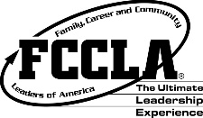
SOUTH DAKOTA FCCLA STATE LEADERSHIP TEAM
APPLICATION INFORMATION SHEET

NAME GRADE

CIRCLE TEAM APPLYING FOR: NATIONAL OUTREACH TRENDS ADVOCACY

CHAPTER SCHOOL

ADVISER ADVISER CELL PHONE

SCHOOL ADDRESS

SCHOOL E-MAIL

HOME ADDRESS

HOME/PERSONAL E-MAIL

HOME PHONE CELL PHONE

PARENTS

NAMES

ADDRESS

E-MAIL PHONE

SCHOOL

PHONE

PRINCIPAL

SUPERINTENDENT

Please use this candidate information sheet as the cover sheet for leadership team application.

Team Purpose:

- Trends Team – Focus on a national program decided upon by the team members.
- National Outreach Team – Focus on outreach goals set by national and state executive councils.
Organization of Teams:
- Each team may consist of up to 10 members.
- Students are eligible to be on each team one year.
- All members through grade 11 are eligible to apply.
- Trends Team will determine national program to focus on annually based on available programs.
- Outreach Team will focus on the national Outreach Program for that particular year.
- Two candidates are allowed to apply per chapter.
- No more than two students can represent a chapter on a team.

Team Responsibilities:
- Term of position is State Leadership Conference to State Leadership Conference.
- Members are required to participate in Fall Training and Winter Training.
- Uniforms will be the expense of the members and will comply with state/national dress code.
- Nametags are to be worn at all official FCCLA events and replacement costs are up to the member.
- Team members will offer workshops as requested during term.
- Write a minimum of three newspaper articles for submission to local paper.
- Present a workshop at region meeting and state meeting.
- Submit monthly reports to coordinator.
- Compile a portfolio throughout the year to be used during exit interview.
- Act professionally at all FCCLA functions – local level to national level.
- Failure to meet the responsibilities as stated will result in probation. The second offense will be removal from the State Leadership Team. Failure to attend and participate in Fall Training or Winter Training will result in immediate removal from the team.
Selection:
- Members interested in applying for a state leadership team will need to submit a completed application by March 1, 2017.
- An FCCLA knowledge test will be taken by candidates at the state meeting.
- Candidates will be interviewed by a team comprised of current members, alumni and advisers. No more than six people will serve on the interview committee.
- During the interview, candidates will give a 2-3 minute presentation with a brochure or infographic about a current trend or outreach project they would like to focus on in the upcoming school year. The brochure is the only prop or visual allowed. No other visuals, handouts or costumes will be allowed.
- Selection will be based on 50% interview score, 25% application score, and 25% test score.

Team Purpose:

- Advocacy Team – Enhance the state association through marketing efforts, sponsorships, and alumni.

Organization of Team:

- Team may consist of up to 10 members.
- Former state officers, former national officers, and national officer candidates are eligible for the Advocacy Team and is a current FCCLA member.
- Members may be on this team more than one year.

Team Responsibilities:

- Term of position is State Leadership Conference to State Leadership Conference.
- Members are required to participate in Fall Training and Winter Training.
- Uniforms will be the expense of the members and will comply with state and national dress code.
- Nametags are to be worn at all official FCCLA events and replacement costs are up to the member.
- Team members will offer workshops as requested during term.
- Write newsletter for alumni and facilitate alumni reception at state meeting.
- Members will contact a minimum of five community groups.
- Members will have a minimum of ten sponsor contacts.
- Submit monthly reports to coordinator.
- Compile a portfolio throughout the year to be used during exit interview.
- Act professionally at all FCCLA functions – local level to national level.
- Failure to meet the responsibilities as stated will result in probation. The second offense will be removal from the State Leadership Team. Failure to attend and participate in Fall Training or Winter Training will result in immediate removal from the team.

Selection:

- Eligible members interested in applying for a State Leadership Team will need to submit a completed application by March 1, 2017.
- Candidates will be interviewed by a team comprised of current members, alumni and advisers. No more than six people will serve on the interview committee.
- The interview will be a mock sponsorship meeting in which the candidate will present information as they would to a potential sponsor.
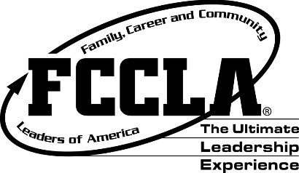

Photography & Website Consent and Release Agreement

I, __________________________, hereby give SD Family, Career and Community Leaders of
America the absolute right and permission to photograph me. I hereby grant to SD Family, Career and Community Leaders of America all rights to reproduce and disseminate such photographs and images, in whole or in part, or altered in character or form, that will be used by the SD Family, Career and Community Leaders of America in conjunction with presentations, programs, and publications.

I further grant SD Family, Career and Community Leaders of America all rights to make further reproductions of such pictures and images through any media, for educational purposes, art, entertainment, advertising of, and internal use for other lawful purposes. I also grant to SD Family, Career and Community Leaders of America the right to copyright such pictures and images in its own name or to publish, to market, and to assign without compensation or report to me.

I hereby waive the rights or interests that I may have in the pictures or images, including my rights to inspect and/or approve the finished photographs and images or the use of which it may be applied so long as its use shall be lawful.

I expressly release SD Family, Career and Community Leaders of America, their agents, employees, licensees and assigns from and against any and all claims which I have or may have for invasion of privacy, defamation or any other case of action arising out of the production, distribution, publication, and exhibition of the photographs and images.

Parent/Guardian Signature ___________________________ Date__________________

Candidate Signature _________________________________ Date _________________

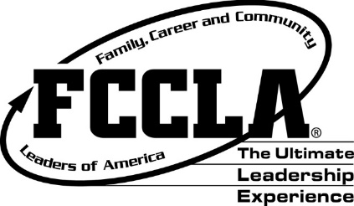

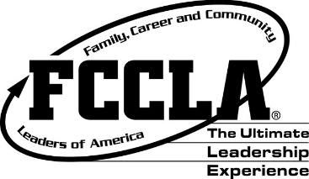

Candidate Support Form

ADMINISTRATOR SUPPORT:

_____ I verify this student is academically eligible for participation as a peer educator/State Leadership
Team.
_____ I understand and support the student attending fall training; a winter/spring meeting;
and the State Leadership Conference in April 2018.
_____ I recommend this student for a peer education/State Leadership Team position.

Signature: _____________________________________________Date:

++++++++++++++++++++++++++++++++++++++++++++++++++++++++++++++++++++++++++++++
ADVISER SUPPORT:

_____ I verify the student applying for this state leadership position is an active FCCLA member
and is capable of fulfilling the responsibility of this position.
_____ I accept the responsibility to support the student by providing resource information on
individual and team projects and activities.
_____ I understand and support the student attending Fall Training; a winter/spring meeting;
and the State Leadership Conference in April 2018.

Signature: ____________________________________________ Date:

+++++++++++++++++++++++++++++++++++++++++++++++++++++++++++++++++++++++++++
PARENT/GUARDIAN COMMITMENT:

_____ I understand and support the training, activities and financial responsibilities involved in
a peer education/State Leadership team position.
_____ I understand and support the student attending Fall Training; a winter/spring meeting; and State
Leadership Conference in April 2018.

Signature: ____________________________________________ Date:

+++++++++++++++++++++++++++++++++++++++++++++++++++++++++++++++++++++++++++++++++++++
STUDENT COMMITMENT:

_____ I understand and accept the responsibilities of the position and I am applying for. I am aware of
the Fall Training dates and financial requirements the position may involve.
_____ I understand that I will be required to attend Fall Training; a winter/spring meeting; and the State
Leadership Conference in April 2018.
_____ I understand there is a dress code the team members are required to follow and responsible for
purchasing.

Signature: _____________________________________________ Date:

