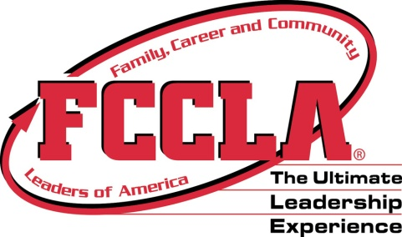

South Dakota FCCLA State Leadership Team Coordinator Application
Current Trends Team

Name __________________________________________________________________
School or Current Position _________________________________________________
State FCCLA Experience:
- State Officer(s):
- District/Region Officer(s):
- Peer Educator(s):
Have you previously served as a State Leadership Team/Peer Educator Coordinator?
Have you had any other leadership positions in FCCLA?

What talents and skills do you feel you could contribute to the role of State Leadership Team Coordinator?

Why would you like to serve as a State Leadership Team Coordinator?

Return to Kris Brockhoft, South Dakota FCCLA, 103 Wenona Hall, Box 507, SDSU, Brookings, SD 57007 or send to Kris.Brockhoft@sdstate.edu by March 15, 2018.

