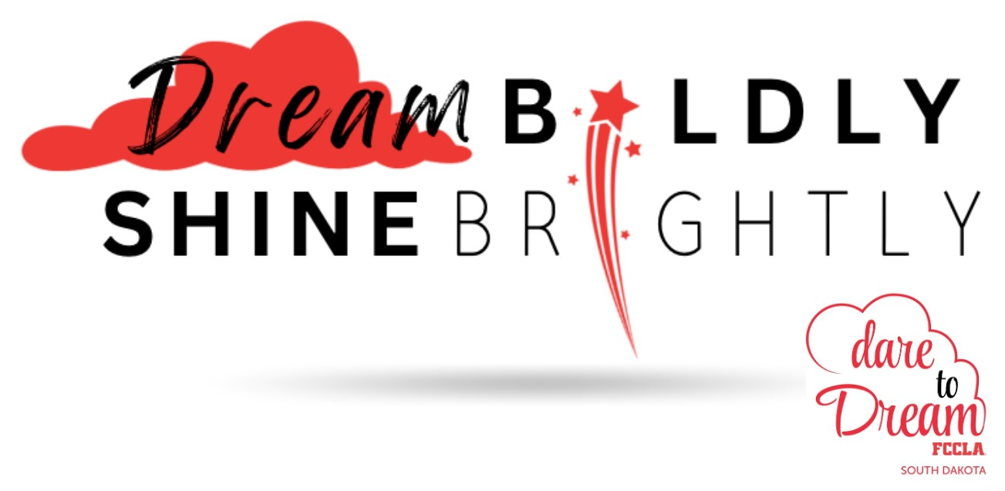
YOU ARE INVITED
2024 FALL LEADERSHIP TRAINING
October 6-7, 2024 ~ Huron, SD
Who: New & returning members, chapter officers,
potential officers, advisers, potential advisers, etc.
Select from one of the following -
- Rookie Training Camp – New(er) Members in Grades 6-9
- Power Training Camp – Returning Members in Grades 8-12
- State Leadership Team Training
- Teens As Teachers – South Dakota YOUTH Foundation. Members interested will use QR Code on Fall Leadership registration form.
- Advisers – New, Potential, & Returning
New Adviser Training-Sunday 5-7:00 PM
When: October 6-7, 2024 (Sunday 5:00 – 9:30 pm)
(Monday 8:00 am-2:30 pm)
Where: Crossroads Hotel & Convention Center -
Huron, SD. Hotel Rate- $89.99 + Tax
Registration: $50/person (Includes 2 meals –
Monday breakfast and lunch.
Sunday-eat supper before arrive.
Registration Due: September 20, 2024
Hotel Reservations: Reserve Today - 605-352-3204
Submit Registration/Payment to:
SD FCCLA
Attn: Kris Brockhoft
103 Wenona Hall, Box 507, SDSU
Brookings, SD 57007

2024-2025 SD FCCLA Theme:
“Dare to Dream ~ Dream Boldly, Shine Brightly!”
Dare to Dream in FCCLA while exploring a future of possibilities where passion meets purpose and dreams become reality. FCCLA serves as your launchpad to success, fostering the skills and inspiration essential for college and career achievement in Family and Consumer Sciences.
Join us in crafting the story of your future—
one daring dream at a time.

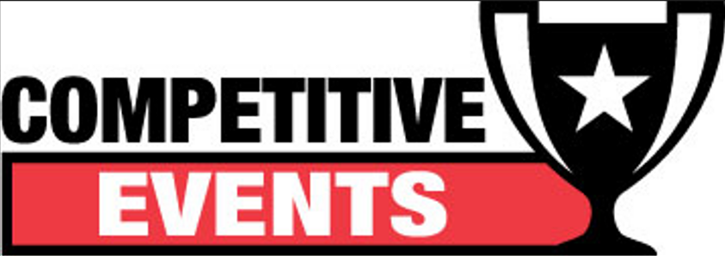

Region STAR Events: Members may compete
in Professional Presentation at the Region Level for the 2024-2025 FCCLA year. Participants receiving gold medals advance to compete
at the State Leadership Conference in April.



- Plan to attend Fall Leadership Weekend.
- Recruit a Knowledge Bowl team to compete at Region
Competition
- Affiliate in portal by November 1 to receive updates
from the National Office, access to important mailings,
and have access to FCCLA resources in FCCLA portal.
- Regular Membership Dues: $8.00 State - $9.00 National



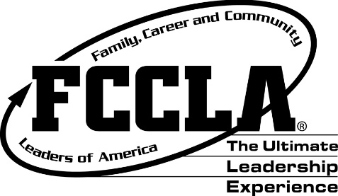
IMPORTANT DATES:
Fall Leadership: October 6-7, 2024, Crossroads Hotel & Convention Center, Huron (Registration Deadline-Sept. 20)
Capitol Leadership: No 2024 Event Due to Election Year
National Fall Leadership Institute: Orlando, FL-October 18-22, 2024 Anaheim, CA-October 24-27, 2024
Region Meetings: R1 Jan. 29, 2025; R2 Dec. 4, 2024; R3: Jan. 15. 2025; R4: Dec. 11, 2024; R5: Dec. 4, 2024; R6: Jan. 6, 2025
FCCLA Week: February 10-14, 2025 (See national website for ideas to celebrate each day.)
State FCCLA Leadership Conference: April 27-29, 2025, Ramkota Convention Center, Sioux Falls
National Leadership Conference-Orlando, FL: July 5-9, 2025
www.fcclainc.org www.sdfccla.org

