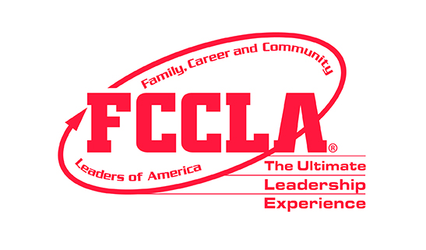
South Dakota FCCLA
Fall Leadership Conference Registration
“Dare to Dream ~ Dream Boldly, Shine Brightly!”

October 6-7, 2024

Crossroads Hotel & Convention Center

100 4th St SW, Huron, SD 57350
Phone: 605-352-3204
FCCLA Room Block: $89.99/Room

Check the appropriate box:
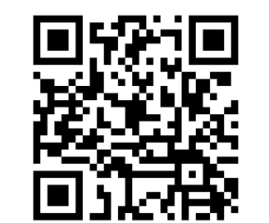
Rookie Training (Grades 6-9) Power Training (Grades 9-12) Leadership Team Training
State Officer Adviser Teen Teachers
NEW ADVISER TRAINING - 5:00-7:00 PM Scan & submit TT application
2024-2025 Leadership Team Training – check the appropriate box:
Current Trends Team National Outreach Team Advocacy Team


SKILL DEMONSTRATION EVENTS provide opportunities for members to demonstrate college & career ready skills in family &
consumer sciences and related occupations. South Dakota FCCLA will provide members with the opportunity to participate in
three Skill Demonstration Events at Fall Leadership Conference. Scan QR Code for more information on Skill Demonstration
Events. Chapters may register up to 3 members in each event. A $3 registration fee charged per student, per event.
Check the appropriate boxes if you would like to participate in one of 3 SKILL DEMONSTRATION EVENTS:
Level I (Through Grade 8) Level 2 (Grades 9-10) Level 3 (Grades 10-12)
  FCCLA Creed Speaking & Interpretation Impromptu Speaking Speak Out for FCCLA
 $50 Registration Fee - Make checks payable to local FCCLA Chapter. Adviser will send one check (no cash) for all
participants, payable to: SD FCCLA, 103 Wenona Hall, Box 507, SDSU, Brookings, SD 57007.
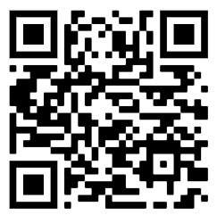
 Include $3 registration fee if member plans to participate in Skill Demonstration Event.
 Adviser will scan & email copy of registration forms to Kristine.Brockhoft@lakeareatech.edu no later than Sept. 20
so meal count and food allergies can be submitted to hotel. Contract requires 2 weeks prior notification to training date.
 Mail hard copy of completed registration forms (after scanning/emailing), consent forms with original signatures, and
check for registration fees (please include registration form for advisers & state/national officers).
Postmark no later than September 20^{th.}
  (Advisers keep original copy of Code of Conduct & Photography Consent/Medical Release Forms in their possession
for travel in case of emergency. Members complete at beginning of year and are kept in folder for easy access when
travel. Forms submitted to state office will be used for State Leadership Conference.)
Participant Name______________________________________ Number of Years in FCCLA: _______
Grade Level:_____ Officer Position for 2024-25:____________________ [Chapter____ Region____]
(If Officer – Check Type)
Name of School/Chapter: __________________________Adviser: _________________________
School Address: _________________________________________________________________

Adviser E-Mail Address: ___________________________________________________________

Adviser Phone Number: School ________________________ Cell ________________________

Food allergies of applicant: _____________________________________ No Allergies ________

Registration - $50 + _____ Skill Demonstration Event = Total $___________

Registrations must be postmarked on or before September 20th. Please scan & email PDF of
completed chapter registration forms in case of delayed or lost mail. Thank you!

